ARC-PA Program Management Portal

Directions for completion of Supervised Clinical Practice Experiences (SCPE) tab

On the Program Detail page, select the SCPE tab.

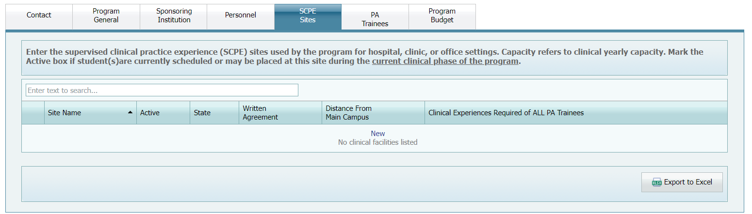

You can add, edit, or delete sites as needed.

Enter the supervised clinical practice experience (SCPE) sites used by the program for hospital, clinic, or office settings.

Hospital = multiple disciplines or single discipline
Clinic = multiple disciplines or single discipline
Office = multiple practitioners or single practitioners

To enter new SCPE sites

1. On the Program Detail page, select the SCPE tab.

2. Click New next to any existing SCPE site.

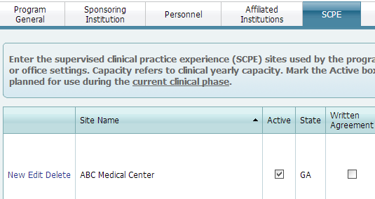

The Add/Edit SCPE Site dialog box appears:

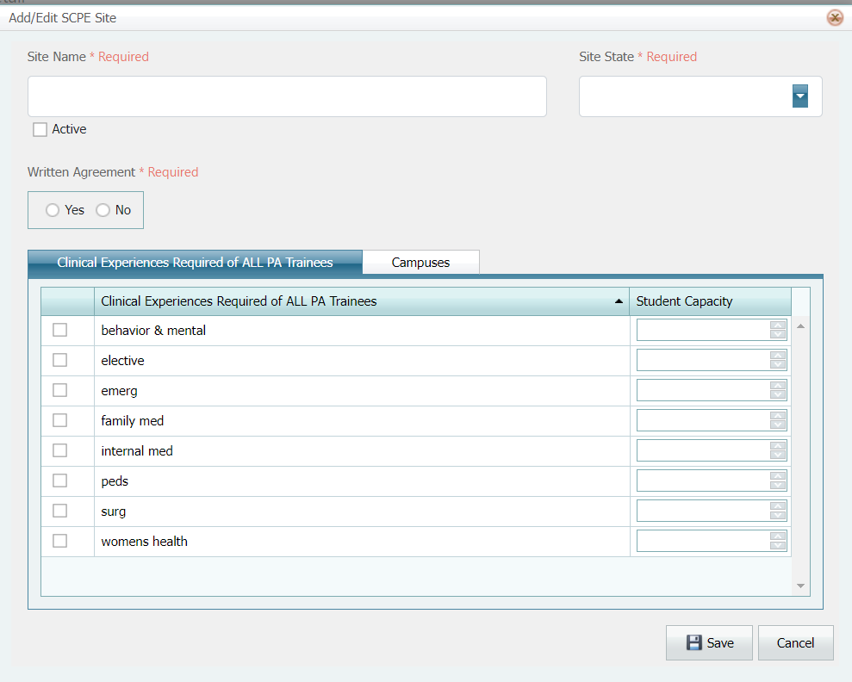

3. Enter the Site Name and Site State

As you enter each site into the program data the portal will arrange your data alphabetically, therefore it is important not to use numbers at the beginning of your Site Name.

Correct Examples:  ABC Medical Center  ABC Medical Center-0001  Jones Family Medicine  Joe Smith, MD | Incorrect Example  0001 ABC Medical Center  Pediatrics – Joe Smith, MD

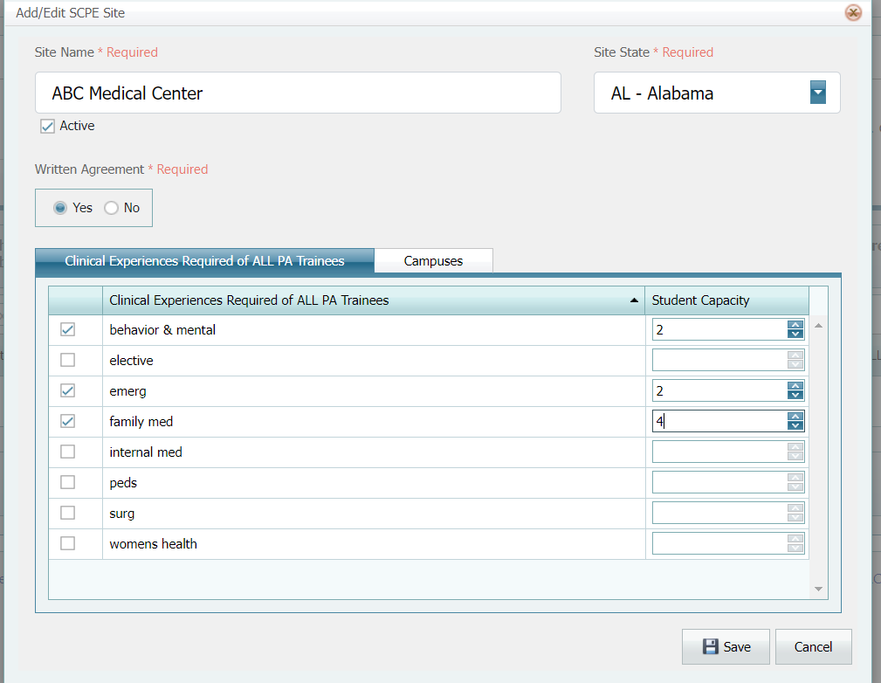
(Example: ABC Medical Center is a multiple discipline setting facility)

4. Mark the site as Active if it is currently being used or if PA trainee (s) will be at this site during the current clinical year.

5. Select Yes or No next to Written Agreement.

NOTE: you must answer all * Required questions as you continue entering data. You will not be allowed to save your work if you have not entered the agreement status.

6. Select the type of setting under the Setting subtab. If the type of setting is not available, you can leave the setting blank. Please remember this is a site location, not a clinical experience.

Emergency department: located in a hospital setting (not an ambulatory/outpatient setting)
Inpatient: setting is within the hospital, patient admitted for care
Operating room: setting is the actual operating room.
Outpatient: setting is ambulatory in nature, patient not admitted for care longer than 24 hours.

7. Next click on the Clinical Experience subtab:

Clinical Experiences:

- Select the check box next to the type of clinical experience offered by the site.
- Enter the maximum number of PA trainees that the site can accommodate for the current clinical year into the PA trainee Capacity field.
- Capacity refers to current clinical yearly capacity.

Example: If you have two (2) providers and each provider can accommodate four (4) PA trainees during the clinical year, you will have a PA trainee capacity of eight (8).

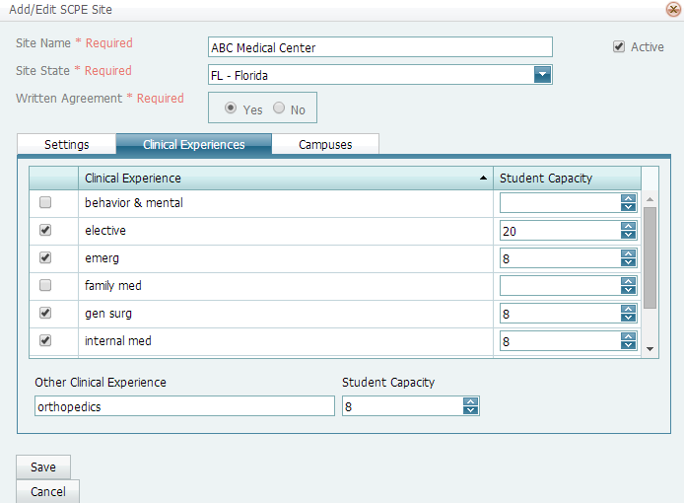
Scroll bar

Note: Remember to use the scroll bar on the right side to see all the required clinical experiences (family medicine, internal medicine, general surgery, pediatrics, ob/gyn, and behavioral and mental health).

- If your choice does not appear, then you can enter the clinical experience in the Other Clinical Experiences field.

- Other Clinical Experiences are only discipline specific experiences required by the program for all PA trainees (i.e., if your program requires that all PA trainees have an orthopedics experience, you will enter orthopedics,).

- Clinical experiences that are not required by the program for all PA trainees are considered electives.

- Electives must not be listed by discipline but by the number for PA trainee capacity that the site will accommodate, regardless of the type of elective. If the site will accommodate 6 PA trainees in a pediatrics elective and 3 PA trainees in a cardiology elective, enter the number 9 in PA trainees Capacity.

- At clinical experience sites that have more than one clinical experience do not enter each specialty in the name.
Correct Example: ABC Medical Center

Incorrect examples:
ABC Medical Center- emergency
ARB Medical Center-gen surgery
ABC Medical Center-cardiology elective
ABC Medical Center-pediatrics elective

- At clinical experience sites that have more than one clinical experience provider, the program should not enter any other provider names. For example, no provider names are required for ABC Medical Center.

- At an office setting clinical experience with a single provider, it may be appropriate to list that site once by the name of the provider, i.e., Joe Smith, MD.

(Each program must maintain information about individual providers (CV, licensure, types, and number of patients, etc.) to demonstrate program compliance with the Standards. Such data is not maintained within the portal.)

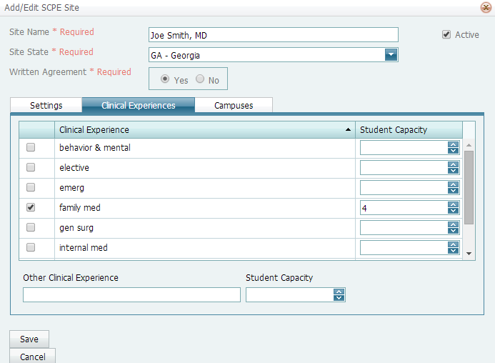

8. Click the Campuses subtab.

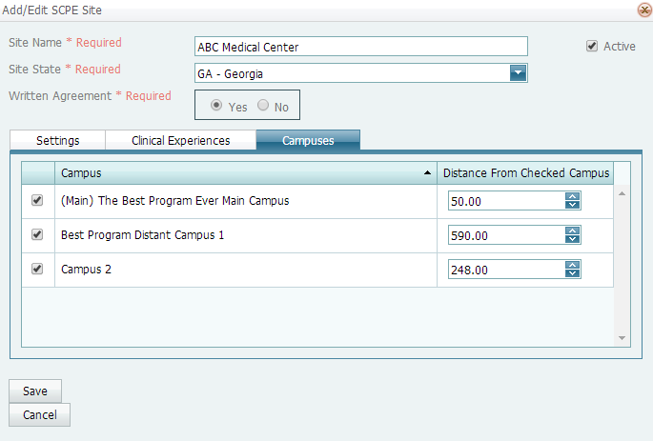

9. Any campuses you have entered under the Program General tab will appear here.

10. Enter the Distance in miles (no decimals required, use conventional round-up/round-down formatting) that the campuses are from the SCPE site.

11. Click Save when you are finished.

To edit SCPE sites

1 From the Program Detail Tab, select the SCPE tab.

2 Click Edit next to the site you want to edit.

3 Edit the fields and then click Save.

To delete SCPE sites

1 From the Program Detail Tab, select the SCPE tab.

2 Click Delete next to the site you want to delete.

3 You are asked if you are sure you want to remove the SCPE site from the program.

4 Click OK. The SCPE site is deleted.

To export SCPE information to a spreadsheet

Note: Make sure that all SCPE information is updated before exporting to Excel.
1 From the Program Detail Tab, select the SCPE tab.
2 At the top of the page, click the Export to Excel button.
The information on the page is exported into an Excel file. Depending on your browser and the version of Microsoft Office you have installed, the Excel spreadsheet may appear in several areas. The file created contains all the information displayed in the columns on the SCPE tab.
3 Open the file. Enable editing, if asked.
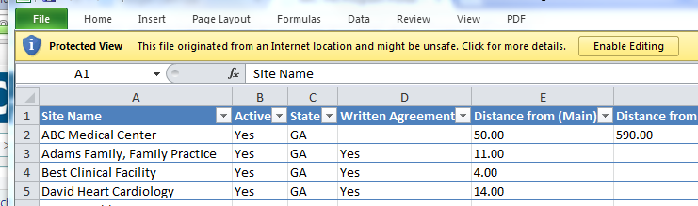

Note: Any changes you make in the Excel file do not affect the SCPE information. To keep the Excel file up to date, you need to use the Export to Excel button each time you use the SCPE tab to add information.
4 Edit the Excel sheet by hiding extra columns to show only the discipline-specific experiences required by the program for all PA trainees (i.e., orthopedics, if required), in the columns for clinical experiences and electives. If you have questions about creating an Excel file and how to hide the extra columns, please contact the IT personnel at your institution. The ARC-PA will not answer questions about how to use Microsoft Office software.

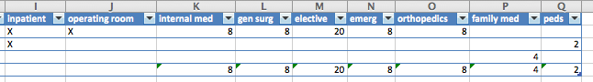

Remember that electives must not be listed by discipline with multiple columns but must be listed under the heading of Electives as they are in the SCPE Clinical Experiences subtab when you add or edit a site.
Elective could include neonatal, plastic surgery, dermatology, ortho, etc. However, these will all simply be listed under the heading of Electives.

There is NO way to download/upload the data for the SCPE tab, due to virus and security issues. The program personnel will have to enter the data and cannot import from databases. Once data is entered in the portal it remains and it may be printed out and uploaded to your computer in various formats.

Examples of Excel sheet as generated from Portal:
Programs with multiple campuses will see that the spreadsheet has columns for distances from each campus, as entered in the portal.
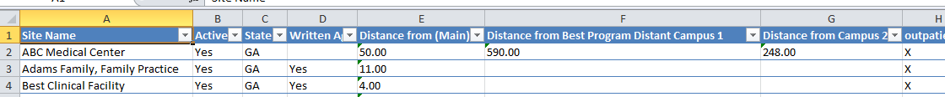

Single campus programs will only have one column for distance from site to campus, as entered in the portal.

The screen shot below represents a single campus program with the correct columns. Orthopedics is listed because it is a SCPE required by the program for all PA trainees.
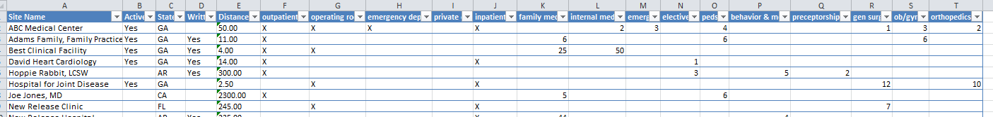

The screenshot below includes a column for the coroner’s office which should not be included. If the coroners’ office is used for an Elective, the site in the portal should list Coroner’s Office and the clinical experience checked should be Elective. To correct this, program personnel must make changes in the portal for each site.

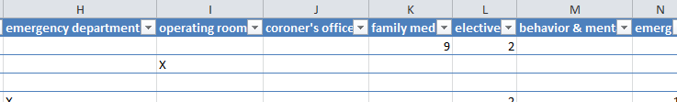

The screen shot below represents a single campus program with two columns that should not be included. Orthopedic surgery is an elective and would not be listed separately. History and Physical examination do not fit the definition of a SCPE and should not be listed. To correct this, program personnel must make changes in the portal for each site.
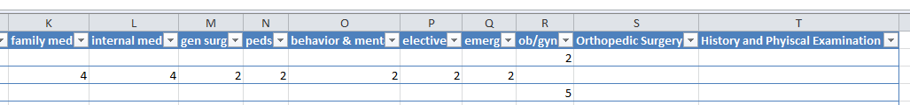

Again, remember that electives must not be listed by discipline with multiple columns, but must be listed under the heading of Electives as they are in the SCPE Clinical Experiences subtab when you add or edit a site.
Elective could include neonatal, plastic surgery, dermatology, ortho, etc. However, these will all simply be listed under the heading of Electives.

