The ARC-PA Program Management Portal: HOW TO BEGIN
March 2024

To access the ARC-PA Program Management Portal (the Portal), you must be invited by the ARC-PA or someone in your program with authorization to invite new users.
New users will receive an email invitation to join the Portal.
When you follow the link in the invitation email you will be taken to the following screen:
SCREEN TO ACTIVATE USER
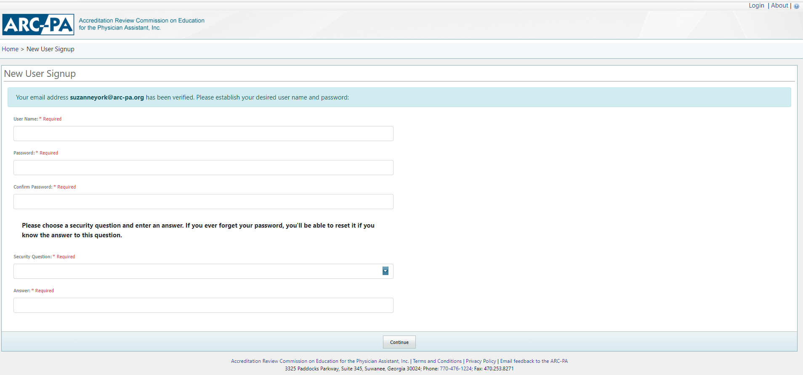
PLEASE follow the directions on the screen to become ACTIVATED in the system.
You will be asked to accept the Terms and Conditions for use of the Portal. After agreeing, you will be taken to the Program Dashboard, your program home page. Users with Program Admin status may then give permission to others in your program to enter data.
It is STRONGLY SUGGESTED that you review the User Manual to help you as you enter data.
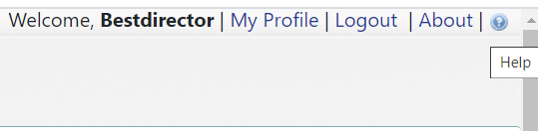

The Postgraduate User Manual can also be found on the ARC-PA website, Portal page, and other useful Portal resources at https://www.arc-pa.org/portal/.
If you have questions that cannot be answered by the Postgraduate User Manual or the resources on the Portal page of the website, email the ARC-PA Portal team by using the “Email feedback to the ARC-PA" link at the bottom of each page of the ARC-PA Program Management Portal. If your email client does not interact with this link, send your comments directly to portalfeedback@arc-pa.org. DO NOT email questions about Portal use directly to the ARC-PA general email or individual staff.

ONLY AFTER you are activated will you be able to access the Portal to enter or edit data. The Portal may be accessed by going onto the ARC-PA website and clicking on Portal Login under Quick Links or by using the following link: https://portal.arc-pa.org.

LOG IN SCREEN FOR ACTIVATED USERS
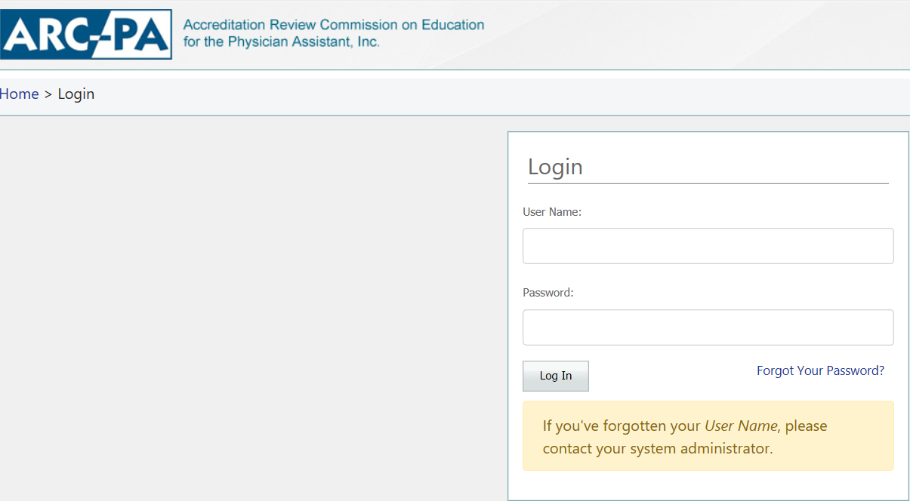
ONCE ACTIVATED, if you have forgotten your Portal username, contact portalfeedback@arc-pa.org. If you have forgotten your password, you may retrieve it or reset it after you enter your user ID.

Steps for Creating Additional Users
Add a new user by clicking on the Personnel tab from the Program Detail page.
Only those with Program Admin status can AUTHORIZE ACCESS to the Portal by others in the program. PLEASE NOTE that those authorized will receive their own email from the Portal and will have to validate their email and establish a user ID before entering information.

To add personnel:
- Click any New link, as shown:
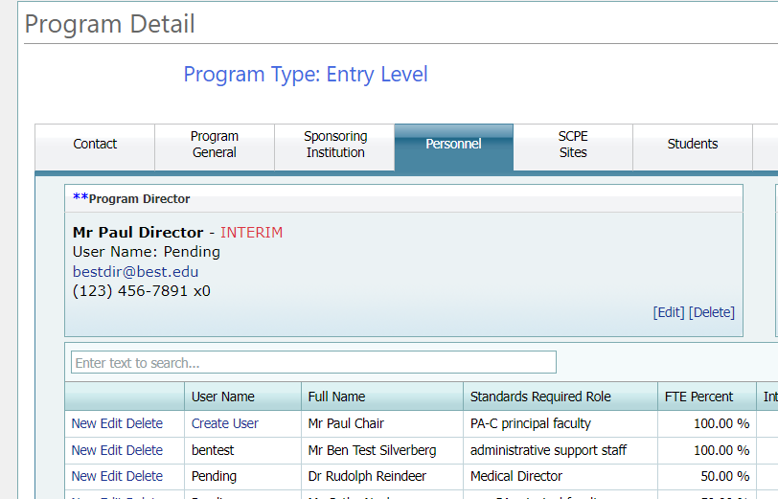
The Add/Edit Person dialog box appears:
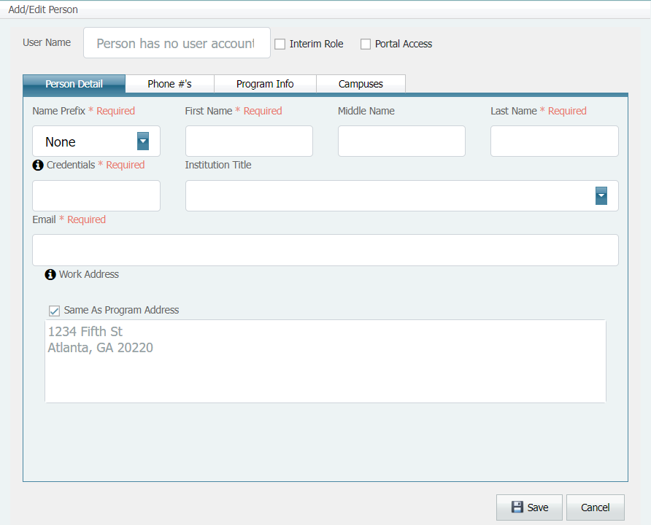
Tabs separate the information: Person Detail, Phone #s, Program Info, and Campuses.

Note: Wait until you have entered information on all tabs to click the Save button at the bottom. Clicking Save saves information you have entered on all tabs AND closes the dialog box.

- Fill in the fields on each tab, as applicable. Refer to the Postgraduate Portal User Manual, Chapter 2, Navigating the ARC-PA Program Portal, Entering Program Detail, Personnel, for instructions.

User Administration tab:
If you want the personnel you have entered to be able to access the Program Portal and enter data, you must make them a Portal User and assign them a User Role. If you do not want them to be able to access the Program Portal and enter data, do not make them Portal Users.

Note: To create a Portal User, the Personnel record must first be saved.
Then see below, to Create a Portal User.

To give Personnel access to the Portal
Starting from the Personnel Table:
- Create a personnel record using the Personnel tab. When you add the person, all required fields must be completed before that person is able to access the Program Portal. Note that in the Username column, the command Create User appears.

- Click Create User as shown:
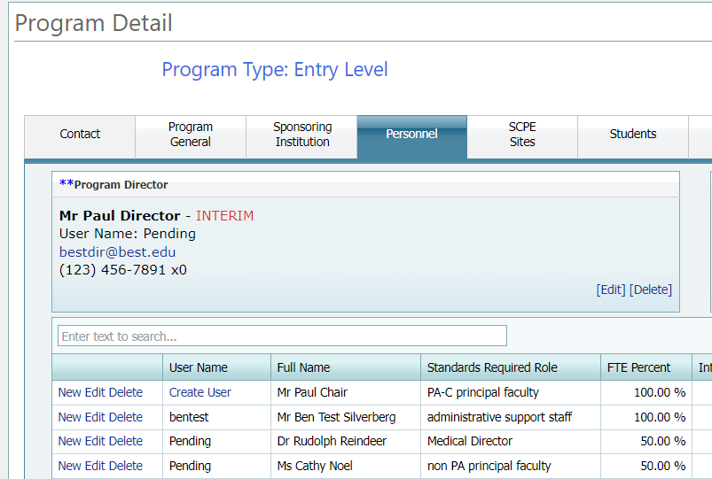
This dialog box appears:
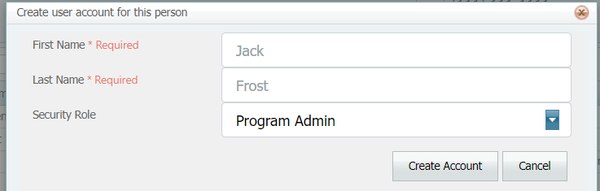
- Select a Security Role
You have these roles to choose from:
Program Admin-- These users are the main contacts for your program including the Program Director or others assigned by the Program Director. These users can enter/see budget data and can submit the program Required Annual Report . They are also able to add, edit and delete personnel from the Portal.
Program Staff--These are the personnel who can edit Portal information needed for accreditation.
- Once you select the role, click Create Account.
This sends the Portal Welcome email to the person you want to set up as a Portal User. The email instructs the person to click on a link to set up their user account.
The column Username shows Pending until the individual clicks the link in the email and sets up their username, password, and security question. When complete, the Username column shows the username entered by the user.
Once a user has configured their account, the Username that the user entered, and the Reset Password link will be visible.

The Add/Edit Person Dialog:
The User Administration tab from the Add/Edit Person dialog can only be used when editing an already existing personnel record. This tab can be used to resend the welcome email or, to reset a user's password once the user has set up a username, password, and security question.
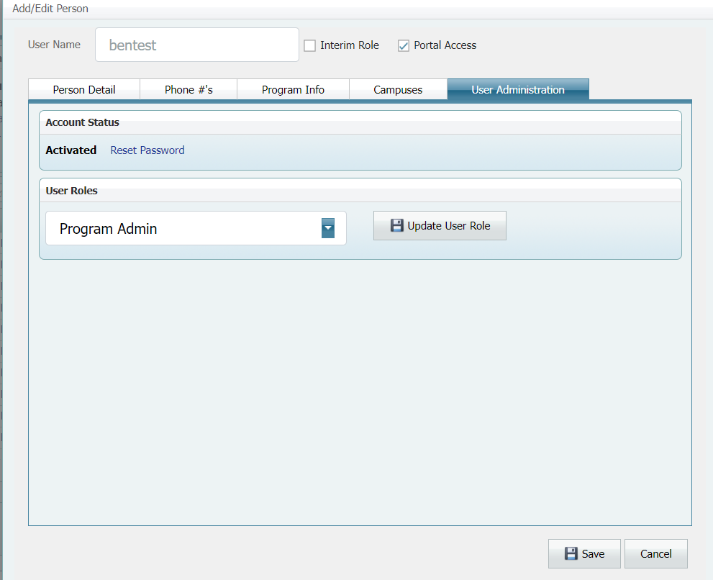
If the user account hasn't been created yet, the Username will have a Create User link available.

To manage a User
Program administrators can manage the accounts a person uses to log into the Portal. Options for sending the user a new password, changing the user's security role, and disabling Portal access are available.

Reset Password
Once the user has completed the account setup process, the Account Status is Activated. In addition, the Reset Password link is available.

- Click the Reset Password link to send an email to the user to initiate the password reset process.
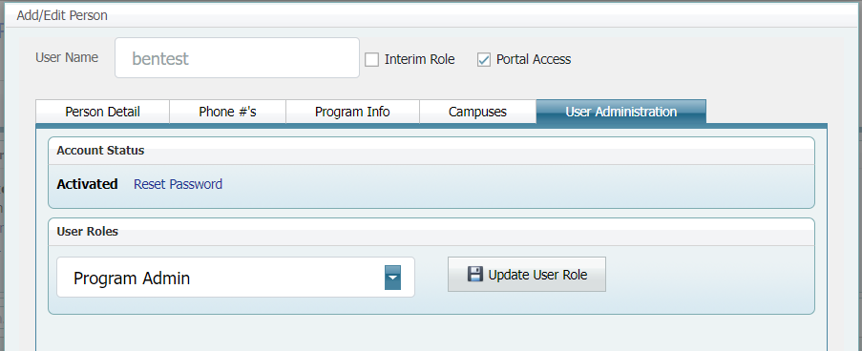
- A confirmation message will appear if the password reset is successful.

Change Role
Follow these instructions if you want to change a user's role.
- Select the role from the User Role drop-down.
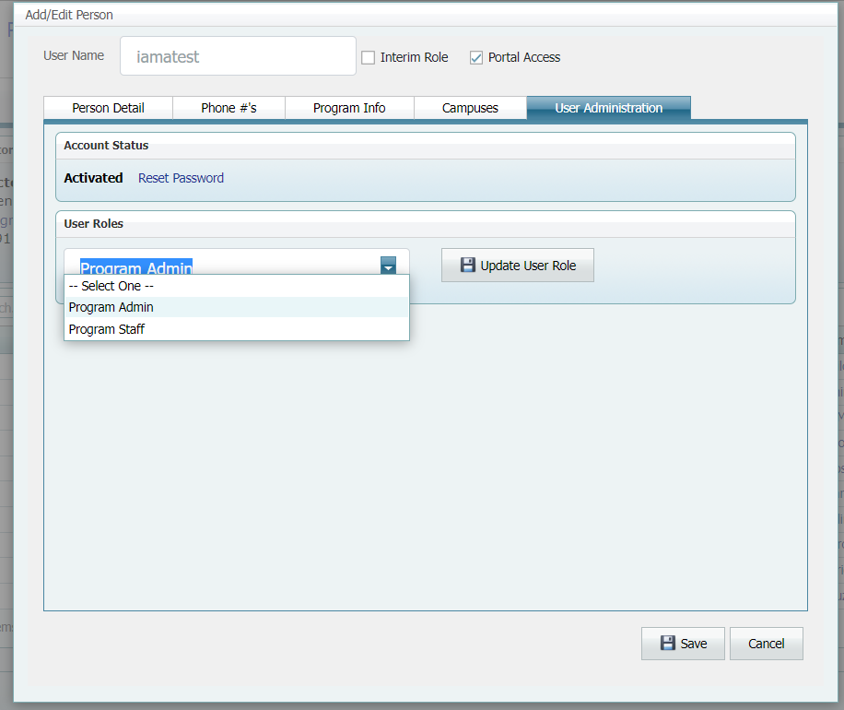
- Select the Update User Role button and Save to close.

Disable Portal Access
Follow these instructions if you want to disable a user's access to the Program Portal.
- Deselect the Portal Access checkbox at the top of the Add/Edit Person screen.
- Select Save.

Please remember the following regarding Personnel Status.
Those with Program Admin status can enter/see budget data and push the Submit button for the annual report. They are also able to edit and delete personnel from the Portal. Additionally, those with Program Admin status may manage the account a person uses to log in. They can re-send the welcome email to re-set passwords, change a user’s security role and disable portal access.
Those with Program Staff status can edit information needed for accreditation. They cannot delete personnel from the Portal. They have no access to/cannot see the budget tab or the Submit button.

IMPORTANT REMINDER, look for and click on SAVE when you see it, after you have entered data. The Contact, Program General, Sponsoring Institution, and PA Trainees tabs have this button at the bottom of the page. Other tab pages such as Personnel, SCPE Sites, and Program Budget have the SAVE button when a separate pop-up window is clicked (such as New, Edit, Delete).

WHEN DOES THE ARC-PA ACCESS PORTAL DATA?
The ARC-PA staff will routinely access the program’s data as noted below. Programs are expected to keep their data accurate and up to date at all times.
- To find contact information for the program director, faculty, staff, chief administrative/academic officer, and the individual to whom the program director reports.
- To verify information entered by the program as a means of updating information in the ARC-PA
files, such as program personnel, regional accreditation status, salaries and budget information, PA trainees enrolled, supervised clinical practice experiences (SCPEs), etc.
- After receiving a change notice of personnel to be sure the change has been documented correctly in the Portal.
- To check on the status of “reports due” to the ARC-PA as required by an accreditation letter.
- During a commission meeting when a program is scheduled on the meeting agenda.
- After receiving a question from the program about its Portal site.
- Concurrently with an authorized program user when that person has asked a question.
- When alerted by the Portal that the program has uploaded a document for submission to the ARC-PA as requested by the ARC-PA.

- When an alert is received for any of the following:
  - Campus added.
  - Change to program length.
  - Sponsoring institution name change.
  - Sponsoring institution regional accreditation status (updated or changed).
  - Chief administrative/academic officer changed.
  - Program director changed.
  - Medical director changed.
  - Interim program director appointed.
  - Interim program director in place longer than 12 months.
  - Change in person to whom the program director reports.
  - Program faculty total does not meet the Standards.
  - Class size exceeds maximum entering ARC-PA approved number.
  - SCPEs (active and agreements in place) are not equal to the number of students in the clinical phase.
  - Reports due, date missed.
Staff will review the Portal of all programs scheduled on an ARC-PA agenda for any action.

