Directions for Using Program Portal to Create Data Sheet for Application OR Report to The ARC-PA
Log into the Portal. From the Home Page, click on Reports on the menu to the left. Select Program Data Sheet. A Report Filter will appear.

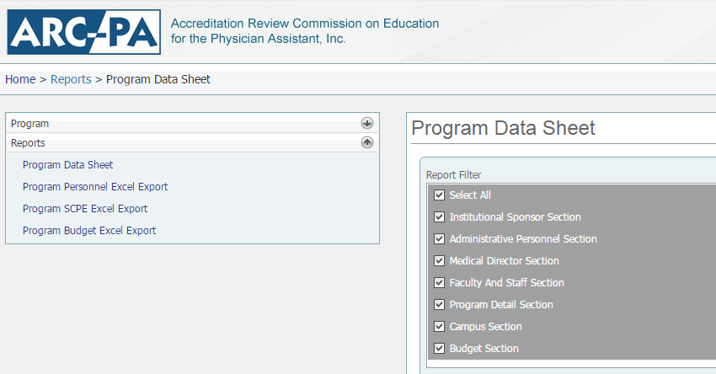
Choose the first option, Select All. When this is selected, all other boxes will automatically be selected as they are important components of the Program Data Sheet for the application.
It may also ask for a “Campus Filter” that allows selection of all campuses or just one at a time. Select the option needed for the report created.
Click on “View” to see the report.
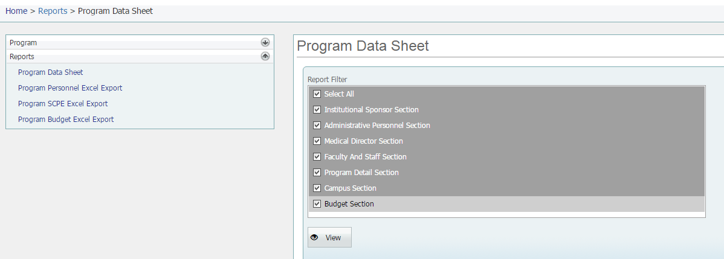
Click on the icon to “Export to” This wording will appear when you hold the cursor over the disk icon.
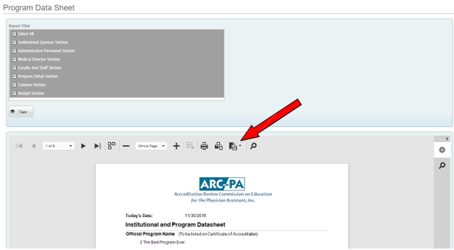

Save the document as a Word file (DOCX) and name it “Program Data Sheet insert program name or abbreviation.” Important Note – Abbreviate as necessary; the title may not exceed 30 characters, including spaces. Do not include commas in the document name.

Keep a copy of the document for your records. Be sure to include the e-copy in the appropriate
appendix as directed in the application form or letter from the ARC-PA.

