Directions for Using Program Portal to Create Program Personnel Excel Export
for Application OR Report to ARC-PA

Log into the Portal. Be sure the personnel tab is up to date. From the Home Page, click on Reports on the menu to the left. Select Program Personnel Excel Export.

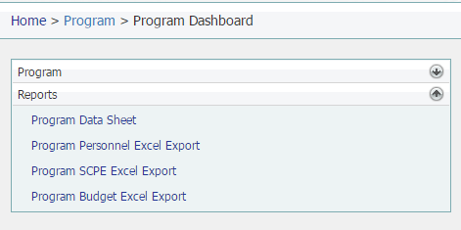
Next, click on “Export.”
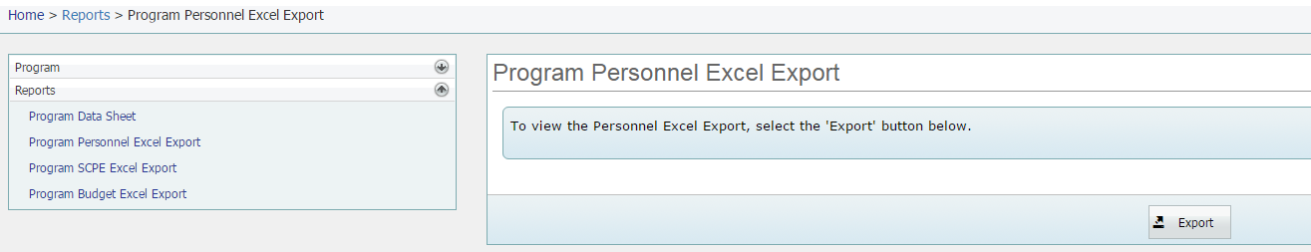
Open the report. (Note that you may have to select “Enable Editing” in order to save the spreadsheet.)
Edit the Excel sheet by clicking on “Data” and then “Sort.”
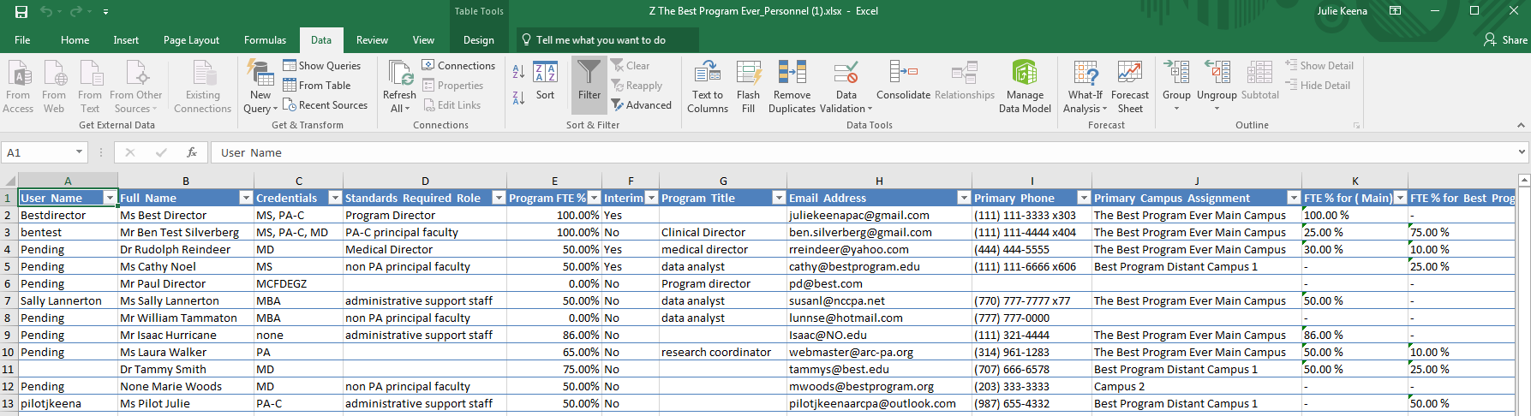

Then click on the drop down by “Sort by” and choose “Standards Required Role” and then click on the “Order” drop down to switch to “Z to A.”

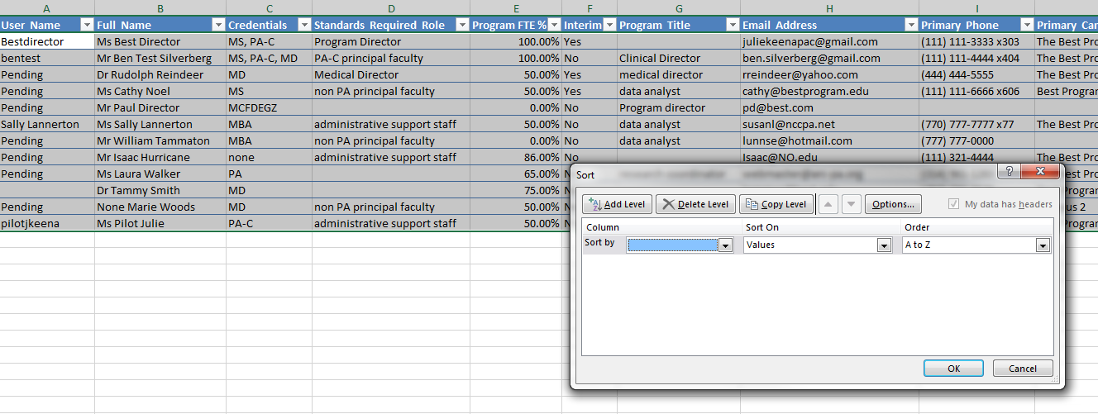

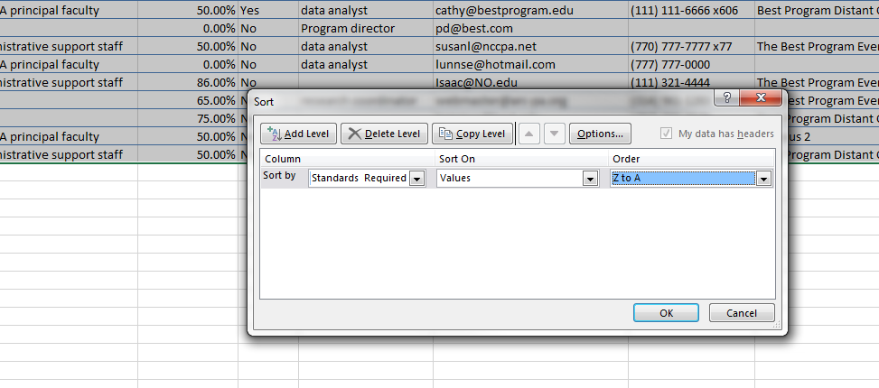
Then click on “Add level”
Click on the drop down for “Then by” and add “Program FTE%” and click on “Order” drop down to change to “largest to smallest” and click “ok.”
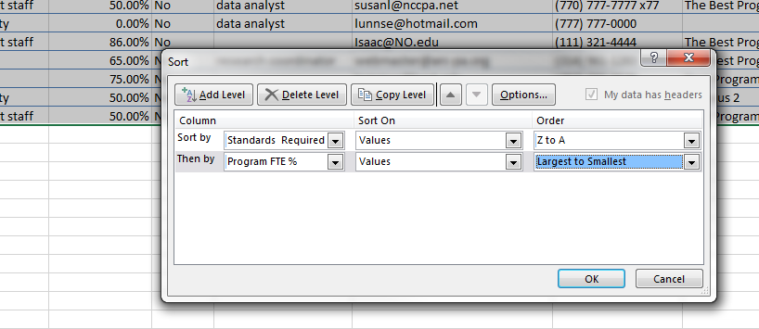

Save the document as directed “Program Personnel insert program name or abbreviation.” Important Note – Abbreviate as necessary; the title may not exceed 30 characters, including spaces. Do not include commas in the document name.
OR the Program Personnel Report can be downloaded from the Program Detail page within the Personnel tab, by clicking on “Export to Excel.”
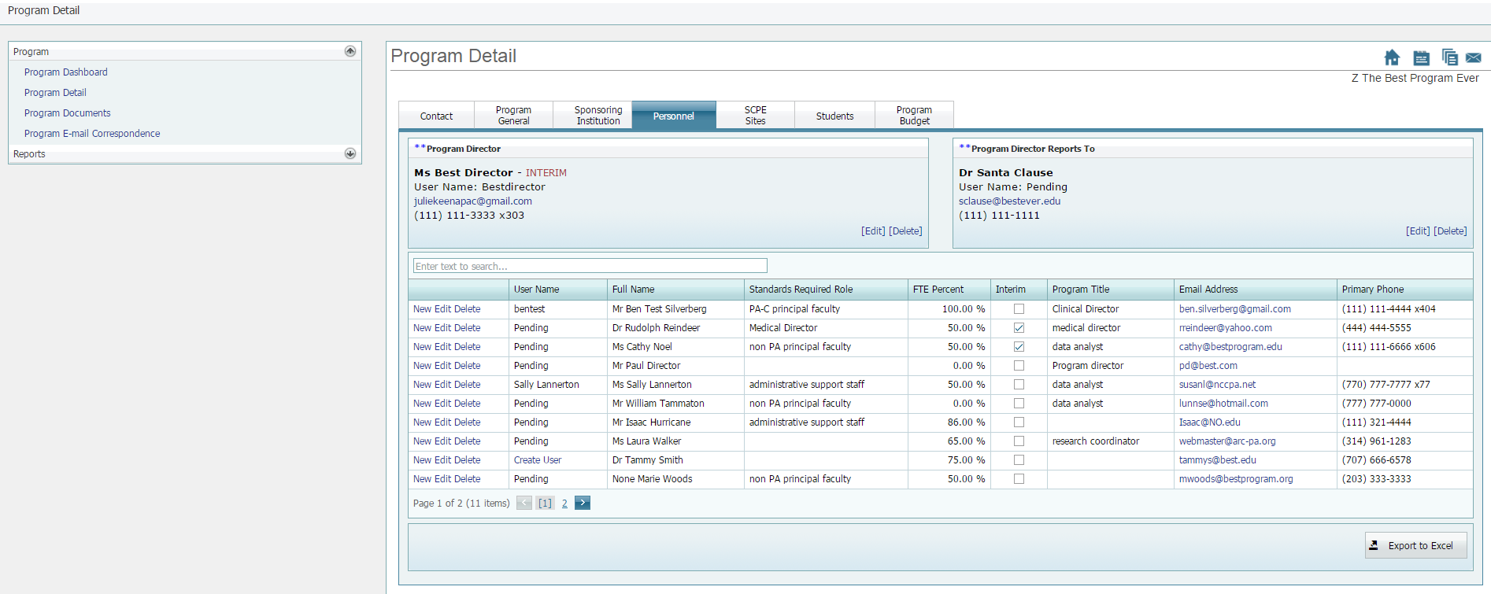
Open the report. (Note that you may have to select “Enable Editing” in order to save the spreadsheet.)
Edit the Excel sheet as indicated above.
Keep a copy of the document for your records. Submit the e-copy in the appropriate appendix as directed in the application form or letter from the ARC-PA.

