Directions for Using Program Budget Portal Tab to Create an Excel Document
for Application Or A Report to the ARC-PA

Be sure that the Program Budget tab in the portal is up-to-date and complete.

At a minimum, the budget detail in the Budget tab must include the following:
- Program budget for salaries, benefits, and development. List the total amount available, whether funds are budgeted from the Postgraduate Program budget, another departmental/institutional budget or both:
  - Program faculty salaries and benefits (for the total # positions budgeted)
  - Staff salaries and benefits (for the total # positions budgeted)
  - Faculty development (Funding provided to the program director and program faculty in support of maintenance of certification, licensure, and professional development directly relevant to PA education)
- Program operations (total program budget less salaries and benefits)

When editing the Program Budget tab on the Portal, remember to hit the “Save” button to save changes you have entered.

- Click on “Reports” and then “Program Budget Excel Export,” then click on “Export.”

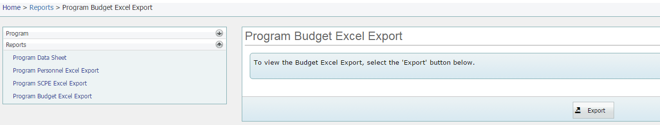

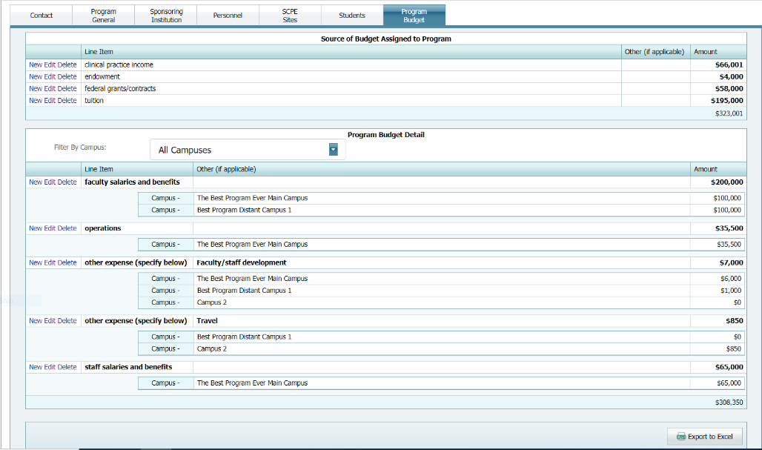
- OR Download the Program Budget tab data to Excel by pressing “Export to Excel” button on the Program Budget tab on the Program Detail page. If you open the page directly you may receive a notice that requires you to “Enable Editing” before you can see the Totals or otherwise use the file.

- Save the downloaded spreadsheet as “Program Budget insert program name/abbreviation” Important Note – Abbreviate as necessary; the title should not exceed 30 characters, including spaces. Do not include commas in the document name.

- On the downloaded copy of the program budget for the application/report please add the following information to the Excel worksheet:

- Add a new column to the right of the last column and title it “FTEs related”

- Add a second column entitled “Budgeted from”

- For program faculty salaries and benefits: indicate in the cell adjacent to the budgeted amount (within the column entitled “FTEs related,” the total number of faculty FTEs this budgeted amount is for. In the next cell adjacent to the FTEs (within the column entitled “Budgeted from”) indicate the budget where this expenditure is funded from, for example, Postgraduate PA Program, Department of Surgery, etc.

- For staff salaries and benefits: indicate in the cell adjacent to the budgeted amount (within the column entitled “FTEs related,” the total number of staff FTEs this budgeted amount is for. In the next cell adjacent to the FTEs (within the column entitled “Budgeted from”) indicate the budget where this expenditure is funded from, for example, Postgraduate PA Program, Department of Surgery, etc.

- Operations: As indicated in the Postgraduate Program ARC-PA Program Portal user manual, operations refer to daily operating expenses such as copying, telephone costs, postage, office and lab supplies, books purchased for the program, software, etc. The program budget has less salaries and benefits.

- For faculty development: indicate in the cell adjacent to the budgeted amount (within the column entitled “FTEs related,” the total number of faculty FTEs this budgeted amount is for. In the next cell adjacent to the FTEs (within the column entitled “Budgeted from”) indicate the budget where this expenditure is funded from, for example, PA Program, College, Dean’s Budget, etc.

Screen shot of the modified Excel budget report for submission:
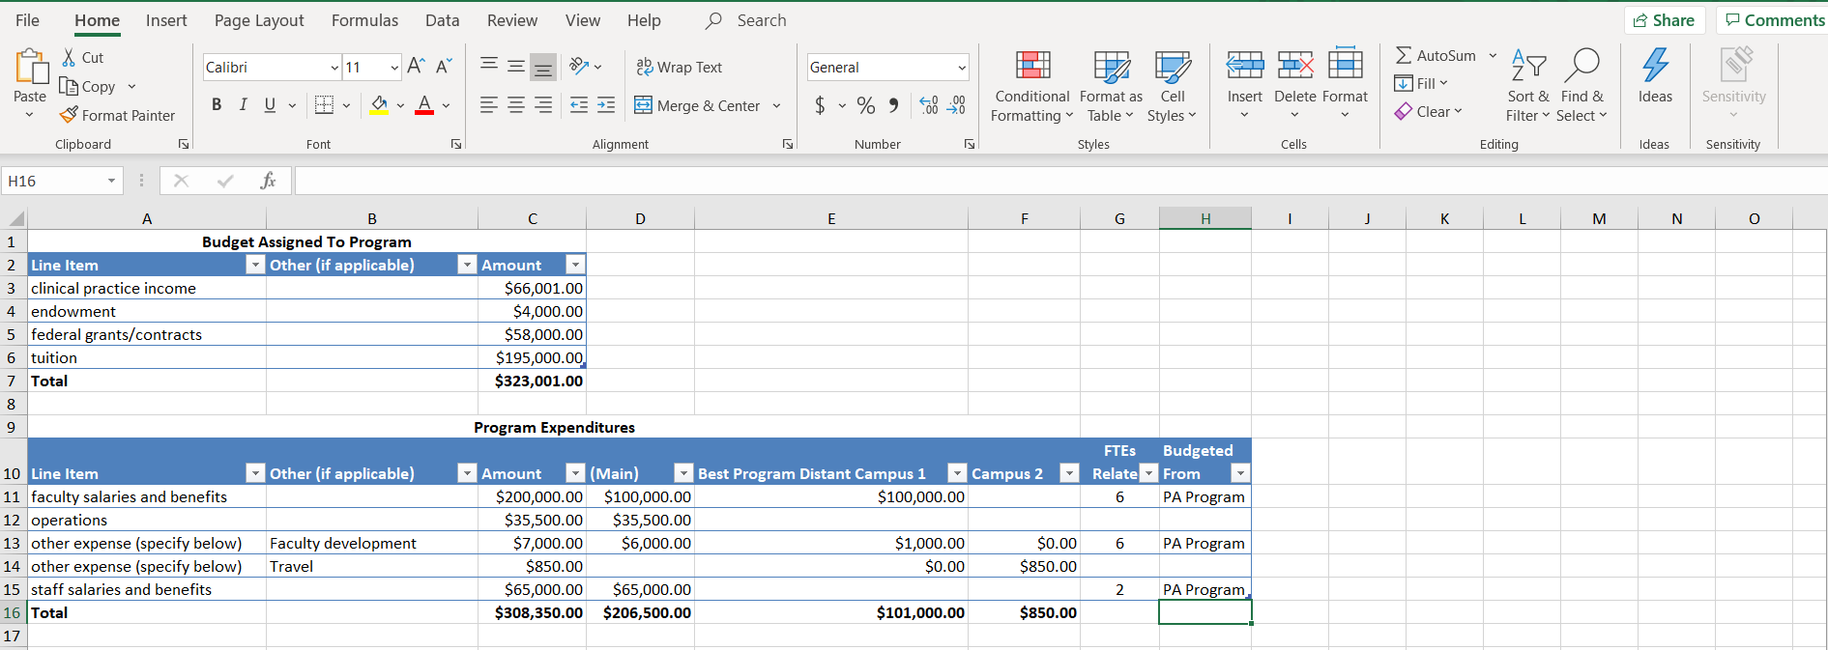
Added columns: FTEs and budgeted from

- Keep a copy of the file for your records. Submit the e-copy in the appropriate appendix or as directed in the application form, or letter from the ARC-PA.

