Annual Report Requirements and Information

Overview

- The Annual Report is all the information in the program’s portal and is generated by the program’s Accreditation Management Portal.
- The Annual Report is generally due each year by July
- For programs first accredited in February, June and September, the first annual report is due the summer following accreditation (July).
- Programs are notified of the deadline for Annual Report submission by email to the Program Director and the Person the Program Director Reports To.
- A Report Due reminder and the Submit button will appear on the Program’s Portal Dashboard page approximately 1 month ahead of the deadline. The reminder will indicate the due date of the Annual Report.
- Since the Annual Report is a combination of all the program’s portal data, it is important that the program updates ALL Portal data fields BEFORE clicking the Submit button.
- If you would like to preserve the information on each of the tabs for record keeping, it is advisable to take a screenshot of the tab before clicking on the Submit button.
- Only the program director (PD) (or those authorized by the PD and given administrative access) is authorized to activate the Submit button.
  - Only the program director may authorize access to the Portal. Those authorized will receive an email from the Portal team and will have to establish a user ID before entering portal information. Simply listing individuals in the Personnel tab does not give those individuals access to the Portal for data entry. It is up to the PD to decide who should be given permission to access and edit the Portal data. It is important that if an individual is to enter data, that person must have his or her own access and not use the login credentials of another individual.
- The Portal is accessed at https://Portal.arc-pa.org. Please note that this link is on the ARC-PA Home page, see Quick Links, Portal Login (http://www.arc-pa.org) for your convenience.
- See also the Portal page of the ARC-PA website for more informationhttp://www.arc-pa.org/portal/

Submit Button
- Only the program director or someone to whom the program director has given appropriate access (program admin) may activate (click) the Submit button, which will appear on the Portal home page for each program. Be sure you are ready to submit the report before clicking Submit, as the report can only be submitted one time. You will see a pop up after submission letting you know your final report data was submitted as entered and has become the document of record. No additional data or reports are to be submitted to the ARC-PA. The electronic submission is all that is required by programs.
- After submission of the Annual Report, the Portal will be unavailable for 1-2 days as the data is processed. Once processed, the portal will become available for routine continuous updating.
- Once you have submitted your report, be sure the Submit button disappears from the Program Dashboard. This will verify for you that your submission occurred.
- IMPORTANT: Data in ALL Tabs, including the SCPE Sites tab, are required to be up to date before submission.

HELP
- Programs should refer to the Postgraduate User Manual by clicking on the question mark in the upper right corner of any page of the Portal for questions about entering data.
- See also the Portal page of the ARC-PA website for more information and tutorials on using the Portal. http://www.arc-pa.org/portal/
- See below for “No Campuses Selected” error.

GENERAL IMPORTANT REMINDERS
- Do not wait too long to update your data. The pop-up windows within a tab may require significant updates in several fields.
- New data fields are added/modified each year and become available on November 15.

Thanks,
ARC-PA Portal Team

UNABLE TO SUBMIT ANNUAL REPORT
“No Campuses Selected” Error
Portal Pop Up Menus Requiring Campus Information

In 2014, the Portal was updated to accommodate the growth in the number of multi campus programs. The Portal now requires ALL PROGRAMS to enter data in Personnel, SCPE, and Program Budget tabs in relation to campus assignment. Multi-campus programs also must specify campuses in the Budget tab.

Not entering this data may result in difficulty submitting your annual report, with error messages back to you.

Single campus programs must specify main campus for the pop-up menus within those tabs.

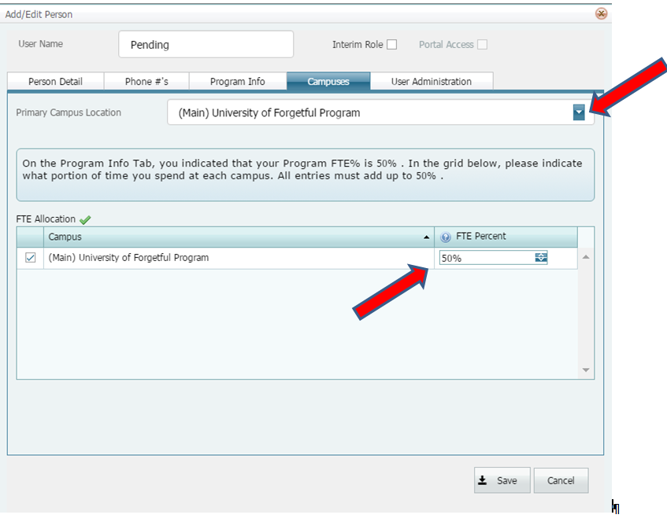

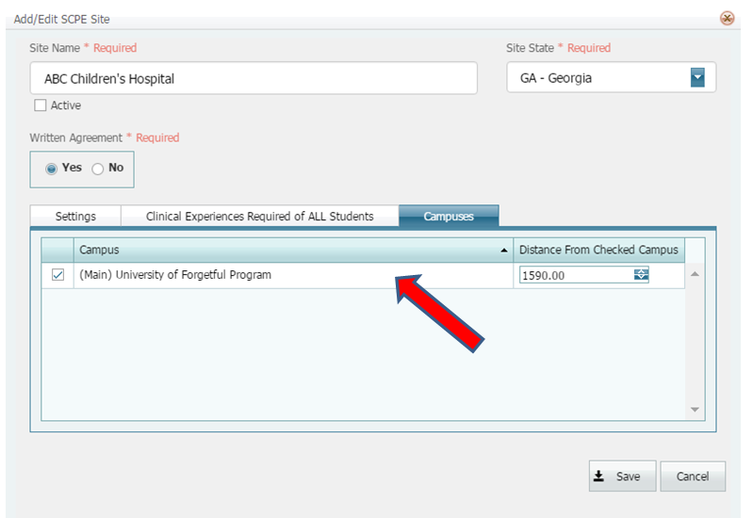
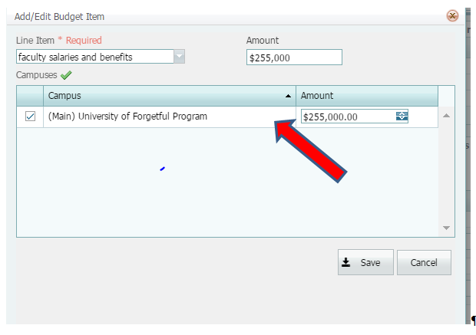
Perfect

Multi campus programs should allocate revenue and expenditures by entering the amount of the line items allocated to each campus.

