Exceeding Class Size Explanation Form
(standard E1.11a)
March 2023

This form is to be used by programs to report information about numbers of students exceeding the maximum entering class size, as noted in the class enrollments entered by the program in the Student Tab of the program portal (sample screen shots below).

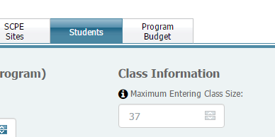

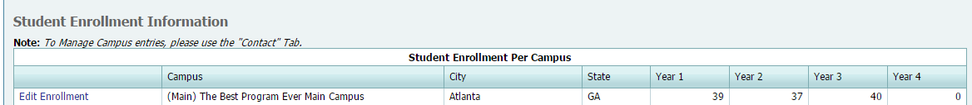

Be sure the student enrollment numbers entered in the program portal are accurate. Please submit this completed form as described below only if the enrollment for any class exceeds the maximum entering class size as in the portal. Retain a copy at your program.

Program Name: Click here to enter program name

Date of form completion: Click here to enter date

Name and title of person completing this form: Click here to enter name and title

Date form submitted to ARC-PA: Click here to enter date

Current approved maximum entering class size on file with ARC-PA and documented in portal | Effective Date
Enter current max class size | Enter effective date

Enter the number of students currently enrolled for each class enrolled as of the date of the form completion. These numbers should match the numbers in the program portal.

Number of students currently enrolled in each year of the accredited program:
Total #
Year 1 enrollment | Enter #
Year 2 enrollment | Enter #
Year 3 enrollment | Enter #
Year 4 enrollment | Enter #
TOTAL current enrollment | Enter total

Provide a narrative description in the boxes below that describes the reasons the class size entered exceeds the approved maximum. Do not provide student names.

The descriptions below may help you in describing the reasons the class sizes listed for any year exceed the approved maximum:

- Deceleration –a student left the class in which s/he entered for reasons including allowing for remediation of deficiencies in the student’s knowledge and skills or personal reasons. The student remains matriculated in the physician assistant program but in the new cohort.

- Leave of absence –a student was given program/institution time away from the program, typically for nonacademic reasons and returned at a later date in another cohort.

- Deferral – a student’s admission was deferred to a cohort that entered after the student’s initial application cohort.

- More students were matriculated into the program than the approved ARC-PA approved maximum entering class size due to institutional admission policies not controlled by the PA program.

NOTE: Do not attempt to embed any tables into the boxes as the formatting does not allow for their integrity to be maintained.

Describe the reasons for exceeding maximum class size for each of the years listed below, as applicable:

Current first year class (listed in portal as Year 1)

Click here to enter text

Current second year class (listed in portal as Year 2)

Click here to enter text

Current third year class (listed in portal as Year 3)

Click here to enter text

Current fourth year class (listed in portal as Year 4)

Click here to enter text

Enter other comments to help explain the excess of class size for any year.

Click here to enter text

Provide a narrative describing the program’s actions that were identified to ensure it does not exceed max class size in the future. If no actions were identified, please indicate “Not applicable”.

Click here to enter text

SUBMISSION INSTRUCTIONS

**This form must be submitted within one week of the program’s receipt of the portal alert.**

The ARC-PA will review this form and any accompanying materials either by an expedited review process or at its next regularly scheduled meeting, as determined by the ARC-PA, in March, June or September. Forms submitted on or before October 1 are considered for the March meeting. Forms submitted on or before February 1 are considered for the June meeting. Forms submitted on or before May 15 are considered for the September meeting. The program may be required to submit additional information, if requested by the ARC-PA.

The program should submit this form by uploading it as an Exceeding Class Size Explanation form in the program’s portal. From the portal Program Dashboard, click on Manage Program Documents in the Action Center or click the Documents icon, which looks like several sheets of paper, in the dashboard’s upper-right corner. Click on the link to the pdf Help document “How to Upload.”

Receipt of this Exceeding Class Size Explanation will be acknowledged by the ARC-PA via correspondence sent to the program.

Statements and Signatures

I understand and agree that the Program will be subject to an adverse accreditation action which could include denial of accreditation or withdrawal of accreditation, and that future eligibility for accreditation may be denied in the event that any of the statements or answers made in this submitted response are false or in the event that the Program violates any of the policies governing accredited programs.

Response Submitted by: Click here to enter name Date: Click here to enter date

Program Director: Click here to enter name Date: Click here to enter date
The name that appears here is deemed an electronic signature.

Institutional Official Program
Director Reports To: Click here to enter name Date: Click here to enter date
The name that appears here is deemed an electronic signature.

**Completed Statement and Signature page must be submitted with this report, otherwise the report will not be accepted.**

