10/14/2022

What is the PROGRAM REQUIRED ANNUAL REPORT?

- The Annual Report is all the information in the program’s portal and is generated by the program’s Accreditation Management Portal.
- The Annual Report is generally due each year by December 15th.
- For programs first accredited in September and June, the annual report is due the spring following accreditation (March 31) and then yearly in December.
- For programs first accredited in March, the annual report is due December 15 of the same year.
- Programs are notified of the deadline for Annual Report submission by email to the Program Director and the Person the Program Director Reports To.
- About one month prior to the report submission deadline, a Report Due reminder and the Submit button will appear on the Program’s Portal Dashboard page. The reminder will indicate the due date of the Annual Report.
- Since the Annual Report is a combination of all the program’s portal data it is important that the program update ALL Portal data fields BEFORE clicking on the Submit button.
- Programs are not required to maintain the Annual Report tab. It is completed only once a year for the Annual Report. The fields in the Annual Report tab reset to zero after you click the Submit button on the program dashboard, and the data from the tab does not populate on the downloadable program data sheet. If you would like to preserve the information on the Annual Report tab, it is advisable to take a screenshot of the tab before clicking on the Submit button.
- Only the program director (PD) (or those authorized by the PD and given administrative access) is authorized to activate the Submit button.
  - Only the program director may authorize access to the Portal. Those authorized will receive an email from the Portal team and will have to establish a user ID before entering portal information. Simply listing individuals in the Personnel tab does not give those individuals access to the Portal for data entry. It is up to the PD to decide who should be given permission to access and edit the Portal data. It is important that if an individual is to enter data, that person have his or her own access and not use the user access of another individual.
- The Portal is accessed at https://Portal.arc-pa.org. Please note that this link is on the ARC-PA Home page, see Quick Links, Portal Login (http://www.arc-pa.org) for your convenience.
- See also the Portal page of the ARC-PA website for more information and tutorials on using the Portal. http://www.arc-pa.org/portal/

Submit Button
- Only the program director or someone to whom the program director has given appropriate access may activate (push) the Submit button, which will appear on the Portal home page for each program. Be sure you are ready to submit the report before pushing the button, as the report can only be submitted one time. You will see a pop up after submission letting you know your final report data was submitted as entered and has become the document of record. No additional data or reports are to be submitted to the ARC-PA. The electronic submission is all that is required by programs.
- After submission of the Annual Report, the Portal remains available for program use except for the Annual Report tab which is completed only once a year and resets to zero after you click the Submit button.
- Programs may download and save the Program Data Sheet (Annual Report) for their records prior to submitting the report or hitting the Submit button.
- Once you have submitted your report, be sure the Submit button disappears from the Program Dashboard. This is the only verification that your submission occurred.
- IMPORTANT: Data in ALL Tabs, including the SCPE Sites tab, are required to be up to date before submission.

HELP
- Programs should refer to the online version of the downloadable pdf, User Manual, for questions when entering data.
- See below for “No Campuses Selected” error
- See also the Portal page of the ARC-PA website for more information and tutorials on using the Portal. http://www.arc-pa.org/portal/

GENERAL IMPORTANT REMINDERS:

- Do not wait too long to update your data. The pop-up windows within a tab may require significant updates in several fields. If even 50% of the accredited programs entering data need help from the Portal team and wait too late, their submission may be delayed.

- If you have questions that cannot be answered by the current on-line HELP menu, User Manual, or Portal page of the website, email the ARC-PA Portal team by using the “Email feedback to the ARC-PA" link at the bottom of each page of the ARC-PA Program Management Portal. If your email client does not interact with this link, send your questions directly to Portalfeedback@arc-pa.org

Thanks,
ARC-PA Portal Team

UNABLE TO SUBMIT ANNUAL REPORT
“No Campuses Selected” Error
Portal Pop Up Menus Requiring Campus Information

In 2014, the Portal was updated to accommodate the growth in the number of multi campus programs. The Portal now requires ALL PROGRAMS to enter data in Personnel, SCPE, and Program Budget tabs in relation to campus assignment. Multi-campus programs also must specify campuses in the Budget tab.

Not entering this data may result in difficulty submitting your annual report, with error messages back to you.

Single campus programs must specify main campus for the pop-up menus within those tabs.

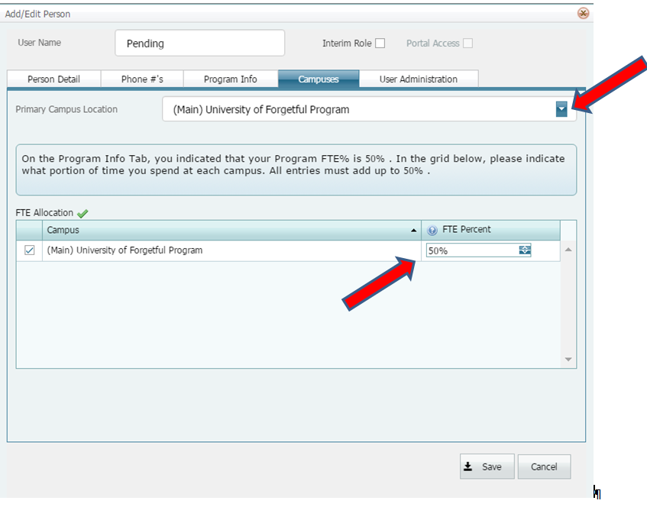

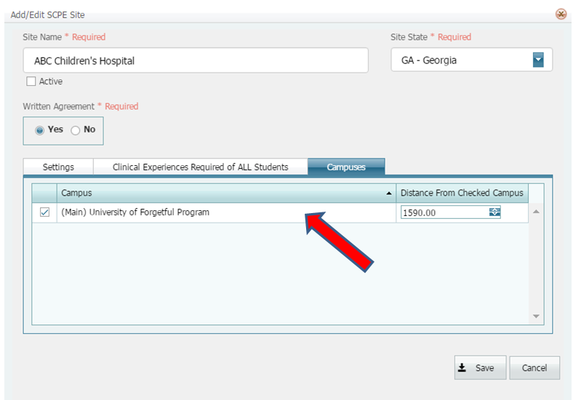
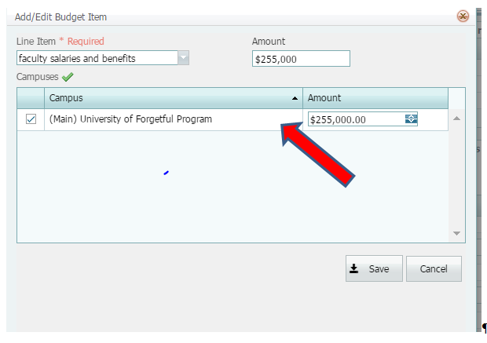
Perfect

Multi campus programs should allocate revenue and expenditures by entering the amount of the line items allocated to each campus.

