How to organize the documents included in the secure document sharing application
(OneDrive, Google Drive, Dropbox, Blackboard)

The supplemental materials required for the site visit team must be available to the site visitors at least seven calendar days prior to the visit. In addition, the directions to access the materials including any login information is to be provided to the site visit chair at least seven calendar days prior to the visit. Material should include items listed on the “On Site Materials List” included in the application and be selected in consultation with the site visit chair.

There should be an overall “Table of Contents” identifying information in the folders and subfolders.

Documents should be organized by standard (e.g., the master folder A Standards, subfolders for each standard A1.01, A1.02)
- Include relevant evidence of compliance that is highlighted or clearly identified in some way. Please do not include an entire document, but only the material relevant to that specific standard. For example, if the evidence is located within the student handbook, include only the page(s) specific to the standard. Or if the evidence is in a course syllabus, only include the page(s) specific to the standard.
- Evidence must include items listed on the “On Site Materials List” included in the application.

Folders with other required documents
- Student records with the documentation as required by the standards, selected per the direction of the site visit chair, including but not limited to:
  - Evidence students met published admission criteria
  - Evidence students met institution and program health screening and immunization requirements
- Student records with the documentation as required by the standards, selected per the direction of the site visit chair, including but not limited to, at least one file per cohort as applicable documenting:
- Advanced placement
- Remediation efforts and outcomes
- Deceleration
- Dismissal
- Academic/Behavioral Disciplinary action
- Graduate records with the documentation as required by the standards, selected per the direction of the site visit chair, including but not limited to:
  - Evidence the graduate met the requirements for program completion.
- Faculty records for the program director, medical director, all principal faculty and course directors with the documentation required by the standards.
- Preceptor records with the documentation as required by the standards including but not limited to:
- Evidence preceptors hold a valid license
- Evidence physician preceptors are specialty board certified in their area of instruction
- Evidence PA preceptors are NCCPA certified
- Evidence other health care providers are qualified in their area of instruction
- Clinical site evaluation records including documentation as required by the standards including but not limited to:
  - Initial and ongoing evaluation of clinical sites that ensures student access to:
    - Physical facilities
    - Patient populations
    - Appropriate supervision

- Committee meeting minutes as needed to support compliance with the standards (organized chronologically and by type)

An empty folder to submit any items/documents requested by the site visit team before or during the visit.

An example of what these folders may look like is shown below:

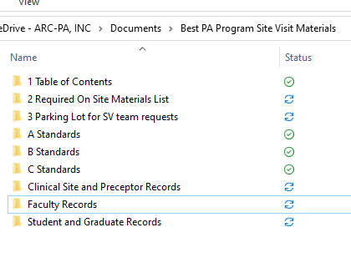
Although this may seem time consuming, in the long run, a program with well-organized documentation will be able to focus on the interactions with the site visitors, rather than trying to find documents requested by the team.
Remember, access to these materials will be removed by the program at the conclusion of the site visit.

If you have questions, do not hesitate to contact the site visit chair.

