UPLOADING DOCUMENTS TO THE PORTAL

From the Program Dashboard, click the Documents icon (looks like sheets of paper) in the upper-right corner.

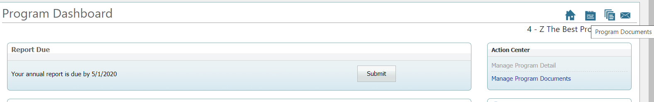

To add documents and reports

- Click New.

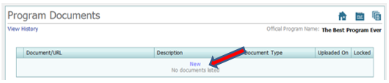
OR

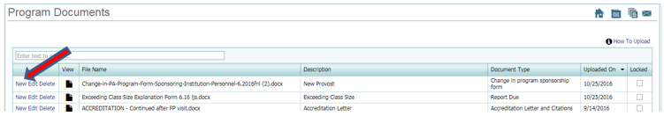

- The Add/Edit Document dialog box appears:

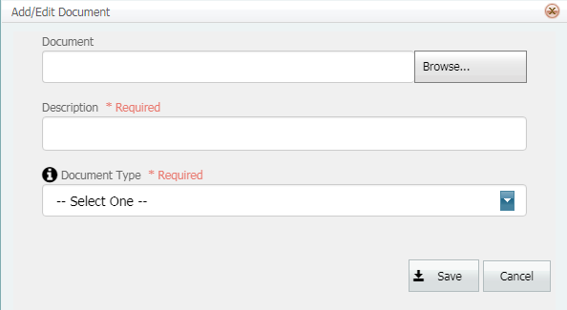

- Click the Browse button to find the document.

NOTE: Document names cannot contain commas.

- Enter a description in your own words of the document that will be seen on the Documents page of your program portal.

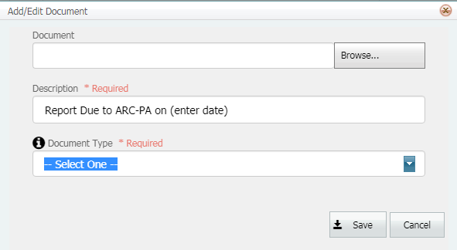

- Choose the type of document you are uploading from the drop-down document list. If you cannot find a corresponding document type in the list, please email the ARC-PA at portalfeedback@arc-pa.org to request that a new document type be added.

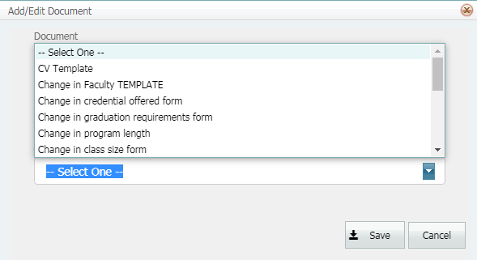

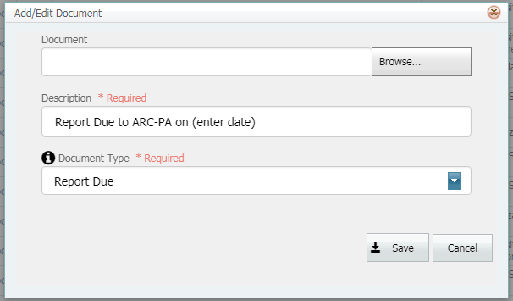

- Click Save when you are finished.

- Do these steps for each document you are attaching.

- Zip multiple related documents prior to being uploaded.

NOTE:

The data limit for documents is 100MB. If the file is greater than 100MB, programs must compress their document to assure proper upload into the portal.

Documents must be uploaded through a high-speed internet connection and completed in less than 15 minutes.

Documents that are too large or take too long to upload will not be accepted by the portal.

Be sure documents are saved in the format and named according to the instructions provided in the report, if applicable.

Once a document is received by the ARC-PA, the documented is indicated as "locked" and
cannot be edited.

